Test Plan
Test Case | Expected Outcome | Actual Result | Pass/Fail
Menu toggle on mobile | Menu opens/closes on click | Works correctly | Pass
All nav links scroll | Each anchor navigates to its section | All links scroll | Pass
Responsive layout < 768px | Layout adjusts correctly on mobile | Fully responsive | Pass
Booking form input | Inputs accept values, layout stays intact | Working as expected | Pass
Hover on buttons/icons | Button color and icon style change on hover | Visual feedback OK | Pass
Footer links | All footer links are clickable | All work | Pass
Script error check | No JS errors in console | No errors | Pass

Index.html
<!DOCTYPE html>
<html lang="en">
<head>
<meta charset="UTF-8" />
<meta name="viewport" content="width=device-width, initial-scale=1.0" />
<link
href="https://fonts.googleapis.com/css2?family=Material+Symbols+Outlined"
rel="stylesheet"
/>
<link
rel="stylesheet"
href="https://cdnjs.cloudflare.com/ajax/libs/font-awesome/6.5.2/css/all.min.css"
integrity="sha512-SnH5WK+bZxgPHs44uWIX+LLJAJ9/2PkPKZ5QiAj6Ta86w+fsb2TkcmfRyVX3pBnMFcV7oQPJkl9QevSCWr3W6A=="
crossorigin="anonymous"
referrerpolicy="no-referrer"
/>
<link rel="stylesheet" href="style.css" />
<title>Hospital</title>
</head>
<body>
<nav class="nav__bar">
<div class="logo">
<span class="material-symbols-outlined"> medical_services </span>
<h2>Lifeline Hospital</h2>
</div>
<ul class="navbar">
<li><a href="#Home">Home</a></li>
<li><a href="#Service">Service</a></li>
<li><a href="#About">About</a></li>
<li><a href="#Doctor">Doctor</a></li>
<li><a href="#Book">Book</a></li>
<li><a href="#Contact">Contact</a></li>
</ul>
<div id="menu__btn" class="fas fa-bars"></div>
</nav>
<hr />
<section id="Home">
<div class="home">
<div class="home__first">
<h2>Compassionate Care, Trusted Professionals</h2>
<p>
At Lifeline Hospital, your well-being is our priority. We are committed to delivering
trusted, compassionate care through advanced medical services and experienced professionals.
From routine check-ups to critical treatments, we ensure you and your family stay healthy,
safe, and supported—every step of the way.
</p>
<button type="button">Contact Now</button>
</div>
<div class="home__second">
<img src="image/home.gif" alt="" />
</div>
</div>
</section>
<section id="Service">
<div class="service">
<div class="service__first">
<i class="fa-solid fa-user-doctor"></i>
<h2>140+</h2>
<p>Doctors at work</p>
</div>
<div class="service__second">
<i class="fas fa-user"></i>
<h2>2400+</h2>
<p>Happy Patients</p>
</div>
<div class="service__third">
<i class="fa-solid fa-bed-pulse"></i>
<h2>250+</h2>
<p>Bed Facility</p>
</div>
<div class="service__fourth">
<i class="fas fa-hospital"></i>
<h2>100+</h2>
<p>Hospital Available</p>
</div>
</div>
</section>
<div class="about__page">
<div class="about__one">
<i class="fas fa-notes-medical"></i>
<h2>Free Checkup</h2>
<p>
Take advantage of our free health checkup services to detect potential health issues early.
At Lifeline Hospital, we believe prevention is better than cure—book your free screening today
for peace of mind.
</p>
<button type="button">Learn More</button>
</div>
<div class="about__two">
<i class="fas fa-ambulance"></i>
<h2>27/7 Ambulance</h2>
<p>
Our fully equipped ambulance service is available 24/7 to respond quickly to emergencies.
Trust Lifeline Hospital for safe and prompt medical transport whenever you need it.
</p>
<button type="button">Learn More</button>
</div>
<div class="about__three">
<i class="fas fa-user-md"></i>
<h2>Experts Consultancy</h2>
<p>
Get personalized medical advice from our team of specialist doctors. At Lifeline Hospital,
we provide expert consultations to help you make informed decisions about your health.
</p>
<button type="button">Learn More</button>
</div>
<div class="about__four">
<i class="fas fa-pills"></i>
<h2>Medicines</h2>
<p>
Access a wide range of trusted and approved medications directly through our in-house pharmacy.
Lifeline Hospital ensures safe, reliable, and convenient medicine support for every patient.
</p>
<button type="button">Learn More</button>
</div>
<div class="about__five">
<i class="fas fa-procedures"></i>
<h2>Bed Facility</h2>
<p>
We offer clean, comfortable, and well-equipped hospital beds to ensure every patient receives
proper rest and round-the-clock care during their stay at Lifeline Hospital.
</p>
<button type="button">Learn More</button>
</div>
<div class="about__six">
<i class="fas fa-heartbeat"></i>
<h2>Total Care</h2>
<p>
Experience comprehensive healthcare services under one roof—from diagnosis to recovery.
At Lifeline Hospital, we’re dedicated to providing holistic, patient-centered care for every
stage of your health journey.
</p>
<button type="button">Learn More</button>
</div>
</div>
<section id="About">
<div class="about__top">
<h2><span>About</span> Us</h2>
</div>
<div class="about">
<div class="about__first">
<img src="image/about.png" alt="" />
</div>
<div class="about__second">
<h2>We take care of your healthy life.</h2>
<p>
At Lifeline Hospital, our mission is to deliver exceptional healthcare with compassion,
innovation, and trust. We believe that a healthy life begins with reliable care—our expert
team works around the clock to ensure every patient receives the highest standard of medical
attention in a safe and supportive environment.
</p>
<p>
Whether it’s preventive care, advanced diagnostics, or specialized treatment, we provide a
full spectrum of services tailored to meet your needs. With a focus on continuous
improvement and patient satisfaction, Lifeline Hospital is your partner in lifelong
wellness.
</p>
<button type="button">Learn More</button>
</div>
</div>
</section>
<section id="Doctor">
<div class="doctor__title">
<h2>Our <span>Doctors</span></h2>
</div>
<div class="doctor">
<div class="doctor__one">
<img src="image/doctor-1.png" alt="" />
<h2>Dr. Mike</h2>
<p>General Medicine,</p>
<div class="media__icon">
<i class="fa-solid fa-phone"></i>
<i class="fa-brands fa-facebook"></i>
<i class="fa-brands fa-linkedin-in"></i>
<i class="fa-brands fa-x-twitter"></i>
</div>
</div>
<div class="doctor__two">
<img src="image/doctor-2.png" alt="" />
<h2>Dr. John</h2>
<p>General Physician</p>
<div class="media__icon">
<i class="fa-solid fa-phone"></i>
<i class="fa-brands fa-facebook"></i>
<i class="fa-brands fa-linkedin-in"></i>
<i class="fa-brands fa-x-twitter"></i>
</div>
</div>
<div class="doctor__three">
<img src="image/doctor-3.png" alt="" />
<h2>Dr. Amanda</h2>
<p>Radiology</p>
<div class="media__icon">
<i class="fa-solid fa-phone"></i>
<i class="fa-brands fa-facebook"></i>
<i class="fa-brands fa-linkedin-in"></i>
<i class="fa-brands fa-x-twitter"></i>
</div>
</div>
<div class="doctor__four">
<img src="image/doctor-4.png" alt="" />
<h2>Dr. Gorge</h2>
<p>Dermatology</p>
<div class="media__icon">
<i class="fa-solid fa-phone"></i>
<i class="fa-brands fa-facebook"></i>
<i class="fa-brands fa-linkedin-in"></i>
<i class="fa-brands fa-x-twitter"></i>
</div>
</div>
<div class="doctor__five">
<img src="image/doctor-5.png" alt="" />
<h2>Dr. Anna</h2>
<p>Gynaecologist </p>
<div class="media__icon">
<i class="fa-solid fa-phone"></i>
<i class="fa-brands fa-facebook"></i>
<i class="fa-brands fa-linkedin-in"></i>
<i class="fa-brands fa-x-twitter"></i>
</div>
</div>
<div class="doctor__six">
<img src="image/doctor-6.png" alt="" />
<h2>Dr.Frank</h2>
<p>Neurologist</p>
<div class="media__icon">
<i class="fa-solid fa-phone"></i>
<i class="fa-brands fa-facebook"></i>
<i class="fa-brands fa-linkedin-in"></i>
<i class="fa-brands fa-x-twitter"></i>
</div>
</div>
</div>
</section>
<section id="Book">
<div class="book__title">
<h2><span>Book</span> Now</h2>
</div>
<div class="book">
<div class="book__first">
<img src="image/book-now.png" alt="" />
</div>
<div class="book__second">
<h2>Book Appointment</h2>
<input type="text" placeholder="Name" />
<input type="text" placeholder="Number" />
<input type="text" placeholder="Email" />
<input type="date" />
<button type="button">Book Now</button>
</div>
</div>
</section>

<footer>
<section id="Contact">
<div class="bottom">
<div class="bottom__one">
<h2>Quick Links</h2>
<ul>
<li>
<a href="#Home"
><i class="fas fa-chevron-right"></i><span> Home</span></a
>
</li>
<li>
<a href="#Service"
><i class="fas fa-chevron-right"></i><span> Service</span></a
>
</li>
<li>
<a href="#About"
><i class="fas fa-chevron-right"></i><span> About</span></a
>
</li>
<li>
<a href="#Doctor"
><i class="fas fa-chevron-right"></i><span> Doctor</span></a
>
</li>
<li>
<a href="#Book"
><i class="fas fa-chevron-right"></i><span> Book</span></a
>
</li>
<li>
<a href="#Contact"
><i class="fas fa-chevron-right"></i><span> Contact</span></a
>
</li>
</ul>
</div>
<div class="bottom__two">
<h2>Our Service</h2>
<ul>
<li>
<a href="#"
><i class="fas fa-chevron-right"></i
><span> Dental Care</span></a
>
</li>
<li>
<a href="#"
><i class="fas fa-chevron-right"></i
><span> Massage Therapy</span></a
>
</li>
<li>
<a href="#"
><i class="fas fa-chevron-right"></i
><span> Cardiology</span></a
>
</li>
<li>
<a href="#"
><i class="fas fa-chevron-right"></i
><span> Diagnosis</span></a
>
</li>
<li>
<a href="#"
><i class="fas fa-chevron-right"></i
><span> Ambulance Service</span></a
>
</li>
</ul>
</div>
<div class="bottom__three">
<h2>Contact Information</h2>
<ul>
<li>
<a href="#">
<i class="fa-solid fa-phone"></i
><span> +61 2 1234 5678</span></a
>
</li>
<li>
<a href="#">
<i class="fa-solid fa-phone"></i
><span> +61 3 9876 5432</span></a
>
</li>
<li>
<a href="#">
<i class="fa-solid fa-envelope"></i
><span> info@lifelinehospital.com.au</span></a
>
</li>
<li>
<a href="#"
><i class="fa-solid fa-location-crosshairs"></i
><span> Sydney, NSW, Australia</span></a
>
</li>
</ul>
</div>
<div class="bottom__four">
<h2>Follow Us</h2>
<ul>
<li>
<a href="#">
<i class="fa-brands fa-facebook"></i><span> Facebook</span></a
>
</li>
<li>
<a href="#">
<i class="fa-brands fa-linkedin-in"></i
><span> Linkdin</span></a
>
</li>
<li>
<a href="#">
<i class="fa-brands fa-x-twitter"></i><span> Twitter</span></a
>
</li>
<li>
<a href="#">
<i class="fa-brands fa-instagram"></i
><span> Instagram</span></a
>
</li>
<li>
<a href="#"
><i class="fa-brands fa-telegram"></i
><span> Telegram</span></a
>
</li>
</ul>
</div>
</div>
<p>2025 Lifeline Hospital. All rights reserved.</p>
</section>
</footer>
<script src="script.js"></script>
</body>
</html>

Style.css
@import url("https://fonts.googleapis.com/css2?family=Poppins:wght@400;500;600;700;800&display=swap");

:root {
--clr-one: #ffffff;
--clr-two: #e0f0ff;
--clr-font: #0077cc;
--clr-text: #333f48;
}
* {
padding: 0;
margin: 0;
box-sizing: border-box;
}
body {
font-family: "Poppins", sans-serif;
}
button {
cursor: pointer;
}
i {
cursor: pointer;
}
/* .container {
margin: 2rem 4rem;
} */
.nav__bar {
display: flex;
justify-content: space-between;
position: fixed;
align-items: center;
width: 100%;
background: var(--clr-one);
padding: 2rem 4rem;
}
.nav__bar .logo {
display: flex;
}
.nav__bar .logo span {
color: var(--clr-font);
padding-right: 1rem;
padding-top: 0.2rem;
}
.nav__bar ul {
display: flex;
list-style: none;
gap: 2rem;
}
ul li a {
color: var(--clr-font);
text-decoration: none;
}
hr {
color: var(--clr-font);
height: 6.4rem;
background: var(--clr-one);
}
/* -------------------------------------- */
.home {
background: var(--clr-two);
display: grid;
grid-template-columns: repeat(2, 1fr);
padding: 2rem 8rem;
}
.home .home__first {
padding-top: 4rem;
}
.home .home__first h2 {
padding: 3rem 0 2rem 0;
color: var(--clr-font);
font-size: 2.2em;
}

.home .home__first button {
padding: 0.6rem 1.9rem;
border: 2px solid var(--clr-font);
border-radius: 0.5rem;
background: transparent;
margin: 2rem 0;
}
.home .home__first button:hover {
background: var(--clr-font);
color: var(--clr-one);
}

.home .home__second img {
width: 400px;
height: 400px;
margin-left: 5rem;
}
/* --------------------------------------- */
.service {
background: var(--clr-one);
display: grid;
grid-template-columns: repeat(4, 1fr);
padding: 8rem;
text-align: center;
gap: 1rem;
}
.service .service__first,
.service .service__second,
.service .service__third,
.service .service__fourth {
border: 2px solid var(--clr-font);
border-radius: 0.3rem;
}
.service .service__first i,
.service .service__second i,
.service .service__third i,
.service .service__fourth i {
font-size: 3em;
padding: 2rem 0;
color: var(--clr-font);
}
.service .service__first h2,
.service .service__second h2,
.service .service__third h2,
.service .service__fourth h2 {
font-size: 2em;
}
.service .service__first p,
.service .service__second p,
.service .service__third p,
.service .service__fourth p {
padding: 1rem 0;
}
/* ------------------------------------- */
.about__page {
background: var(--clr-two);
display: grid;
grid-template-columns: repeat(3, 1fr);
padding: 8rem;
text-align: left;
gap: 1rem;
}
.about__page .about__one,
.about__page .about__two,
.about__page .about__three,
.about__page .about__four,
.about__page .about__five,
.about__page .about__six {
border: 2px solid var(--clr-font);
padding-left: 2rem;
border-radius: 0.3rem;
}
.about__page .about__one i,
.about__page .about__two i,
.about__page .about__three i,
.about__page .about__four i,
.about__page .about__five i,
.about__page .about__six i {
color: var(--clr-font);
font-size: 3em;
padding: 2rem 2rem 1rem 2rem;
}
.about__page .about__one h2,
.about__page .about__two h2,
.about__page .about__three h2,
.about__page .about__four h2,
.about__page .about__five h2,
.about__page .about__six h2 {
padding-bottom: 1rem;
}
.about__page .about__one p,
.about__page .about__two p,
.about__page .about__three p,
.about__page .about__four p,
.about__page .about__five p,
.about__page .about__six p {
color: var(--clr-text);
}
.about__page .about__one button,
.about__page .about__two button,
.about__page .about__three button,
.about__page .about__four button,
.about__page .about__five button,
.about__page .about__six button {
padding: 0.6rem 1.9rem;
border: 2px solid var(--clr-font);
border-radius: 0.5rem;
background: var(--clr-font);
margin: 1rem 0;
color: var(--clr-one);
}
/* ------------------------------------------ */
.about {
display: grid;
grid-template-columns: repeat(2, 1fr);
padding: 5rem 8rem;
gap: 1rem;
background-color: var(--clr-one);
}
.about__top h2 {
text-align: center;
font-size: 3em;
padding-top: 1rem;
background-color: var(--clr-one);
}
.about__top h2 span {
color: var(--clr-font);
}
.about .about__second {
padding-top: 1cap;
}
.about .about__second h2 {
color: var(--clr-font);
font-size: 2em;
padding-bottom: 2rem;
}
.about .about__second p {
color: var(--clr-text);
padding-top: 1rem;
}
.about .about__second button {
padding: 0.6rem 1.9rem;
border: 2px solid var(--clr-font);
border-radius: 0.5rem;
background: var(--clr-font);
margin: 2rem 1rem;
color: var(--clr-one);
}
/* ------------------------------------- */
.doctor {
background: var(--clr-two);
display: grid;
grid-template-columns: repeat(3, 1fr);
padding: 1rem 8rem;
text-align: center;
gap: 1rem;
}
.doctor__title h2 {
background: var(--clr-two);
text-align: center;
font-size: 3em;
padding: 1rem 0 6rem 0;
}
.doctor__title h2 span {
color: var(--clr-font);
}
.doctor .doctor__one,
.doctor .doctor__two,
.doctor .doctor__three,
.doctor .doctor__four,
.doctor .doctor__five,
.doctor .doctor__six {
border: 2px solid var(--clr-font);
border-radius: 0.3rem;
}
.doctor .doctor__one img,
.doctor .doctor__two img,
.doctor .doctor__three img,
.doctor .doctor__four img,
.doctor .doctor__five img,
.doctor .doctor__six img {
width: 100px;
height: 100px;
border: 2px solid var(--clr-font);
margin: 2rem auto;
border-radius: 0.3rem;
}
.doctor .doctor__one h2,
.doctor .doctor__two h2,
.doctor .doctor__three h2,
.doctor .doctor__four h2,
.doctor .doctor__five h2,
.doctor .doctor__six h2 {
color: var(--clr-font);
}
.doctor .doctor__one p,
.doctor .doctor__two p,
.doctor .doctor__three p,
.doctor .doctor__four p,
.doctor .doctor__five p,
.doctor .doctor__six p {
color: var(--clr-text);
}
.media__icon {
text-align: center;
font-size: 1.6em;
padding: 1rem;
color: var(--clr-font);
}
.media__icon i {
padding: 0.6rem;
border: 2px solid var(--clr-font);
border-radius: 0.3rem;
}
/* -------------------------------------------- */
.book {
display: grid;
grid-template-columns: repeat(2, 1fr);
padding: 1rem 8rem;
}
.book__title h2 {
text-align: center;
font-size: 3em;
padding: 3rem 0 6rem 0;
}
.book__title span {
color: var(--clr-font);
}
.book .book__first img {
width: 300px;
height: 300px;
}
.book .book__second {
border: 2px solid var(--clr-font);
}
.book .book__second h2 {
text-align: center;
font-size: 2em;
padding: 2rem 0;
}
.book .book__second input {
display: block;
border: 2px solid var(--clr-font);
color: var(--clr-font);
padding: 0.8rem 1rem;
margin: 0.4rem 1rem;
width: 94%;
}
.book .book__second button {
padding: 0.6rem 1.9rem;
border: 2px solid var(--clr-font);
border-radius: 0.5rem;
background: transparent;
margin: 1rem 0;
margin: 1rem 13rem;
}
.book .book__second button a {
color: var(--clr-font);
text-decoration: none;
}
.book .book__second button:hover {
background: var(--clr-font);
color: var(--clr-one);
}
/* --------------------------------------------- */
.bottom {
display: grid;
grid-template-columns: repeat(4, 1fr);
padding: 5rem 8rem;
background: var(--clr-two);
}
.bottom .bottom__one h2,
.bottom .bottom__two h2,
.bottom .bottom__three h2,
.bottom .bottom__four h2 {
padding-bottom: 1rem;
}
.bottom .bottom__one ul,
.bottom .bottom__two ul,
.bottom .bottom__three ul,
.bottom .bottom__four ul {
list-style: none;
}
.bottom .bottom__one ul li a span,
.bottom .bottom__two ul li a span,
.bottom .bottom__three ul li a span,
.bottom .bottom__four ul li a span {
color: var(--clr-text);
padding-left: 1rem;
}
footer p {
text-align: center;
background: var(--clr-two);
}
/* ----------------------------------------------- */
#menu__btn {
color: var(--clr-font);
font-size: 1.7em;
cursor: pointer;
display: none;
}
@media (max-width: 830px) {
body {
overflow-x: hidden;
}
#menu__btn {
display: initial;
}
.nav__bar .navbar {
position: absolute;
top: 100%;
right: 0rem;
border-radius: 0.5rem;
width: 30rem;
background: var(--clr-one);
display: inline;
text-align: center;
padding-top: 2rem;
border: 2px solid var(--clr-font);
transform: scale(0);
opacity: 0;
transition: none;
transform-origin: top right;
}
.nav__bar .navbar.active {
transform: scale(1);
opacity: 1;
transform-origin: 0.2s ease-out;
}
.nav__bar ul li {
padding-bottom: 1.5rem;
}
.nav__bar ul {
display: none;
}
.home .home__first {
padding-top: 0;
}
.home .home__first h2 {
font-size: 1.5em;
}
.home .home__first p {
font-size: 1em;
}
.home .home__second img {
width: 300px;
height: 300px;
}
.about .about__second h2 {
font-size: 1.4em;
}
.about__page .about__one h2,
.about__page .about__two h2,
.about__page .about__three h2,
.about__page .about__four h2,
.about__page .about__five h2,
.about__page .about__six h2 {
font-size: 1em;
}
.about .about__first img {
width: 300px;
height: 300px;
}
.book {
padding: 1rem 4rem;
}
.bottom .bottom__one h2,
.bottom .bottom__two h2,
.bottom .bottom__three h2,
.bottom .bottom__four h2 {
font-size: 1em;
}
.bottom {
grid-template-columns: repeat(2, 1fr);
text-align: left;
}
}
@media (max-width: 750px) {
.about__page {
grid-template-columns: repeat(2, 1fr);
}
.doctor {
grid-template-columns: repeat(2, 1fr);
}
.book {
grid-template-columns: repeat(1, 1fr);
}
.book .book__first img {
margin-left: 8rem;
}
.about {
grid-template-columns: repeat(1, 1fr);
}
.about .about__first img {
margin-left: 4rem;
}
.service {
grid-template-columns: repeat(2, 1fr);
}
.home {
grid-template-columns: repeat(1, 1fr);
}
}
@media (max-width: 580px) {
body {
overflow-x: hidden;
}
.home {
padding: 4rem 2rem;
}
.home .home__first p,
.about .about__second p {
width: 94%;
}
.service {
grid-template-columns: repeat(1, 1fr);
padding: 4rem 2rem;
}
.about__page,
.about,
.doctor,
.book,
.bottom {
padding: 4rem 2rem;
}
.book .book__first img {
margin-left: 0;
}
.about__page {
grid-template-columns: repeat(1, 1fr);
}
.doctor {
grid-template-columns: repeat(1, 1fr);
}
.book .book__second button {
margin: 1rem 10rem;
}
}

Script.js
const menu = document.querySelector("#menu__btn");
const navbar = document.querySelector(".navbar");

menu.onclick = () => {
menu.classList.toggle("fa-times");
navbar.classList.toggle("active");
};
window.onscroll = () => {
menu.classList.remove("fa-times");
navbar.classList.remove("active");
};
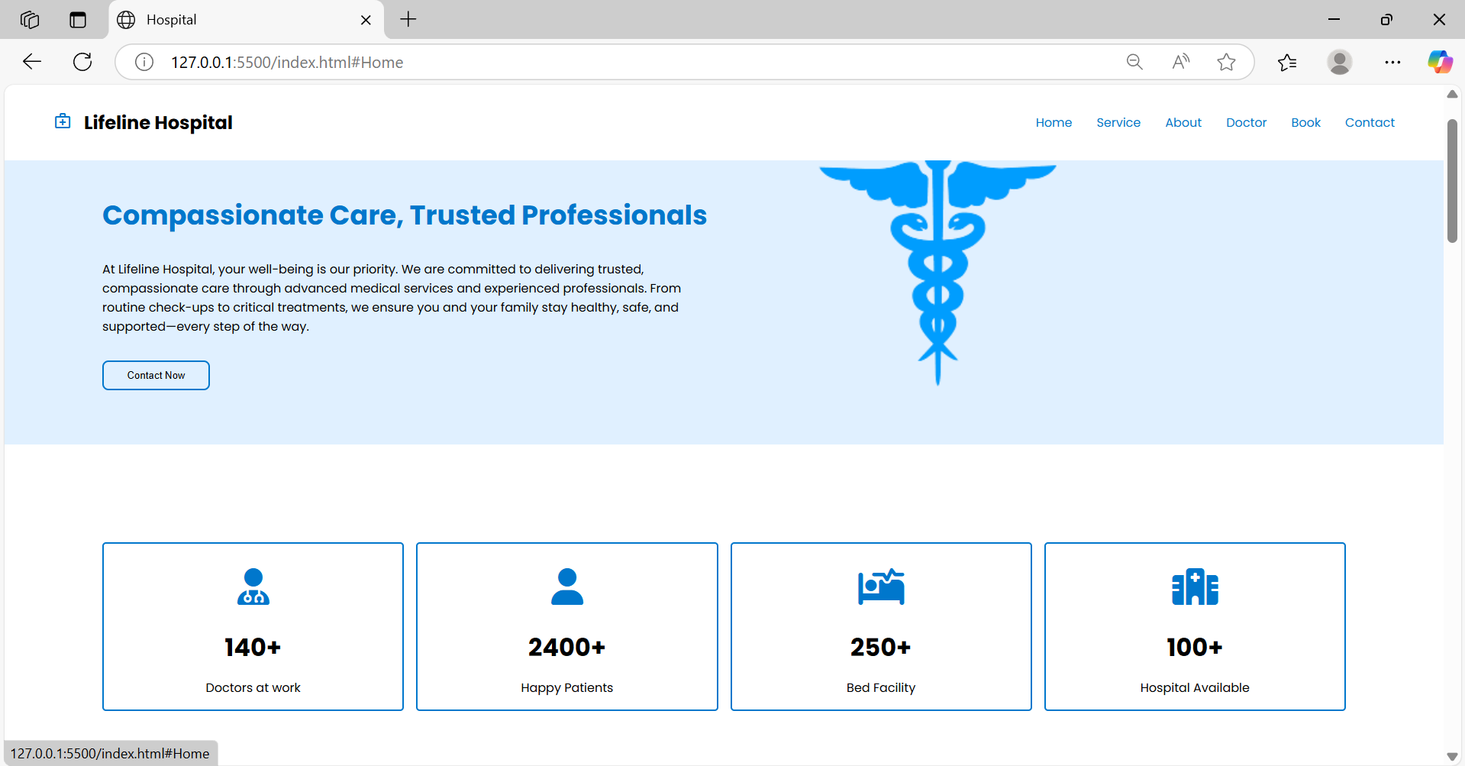
Figure 1: Homepage
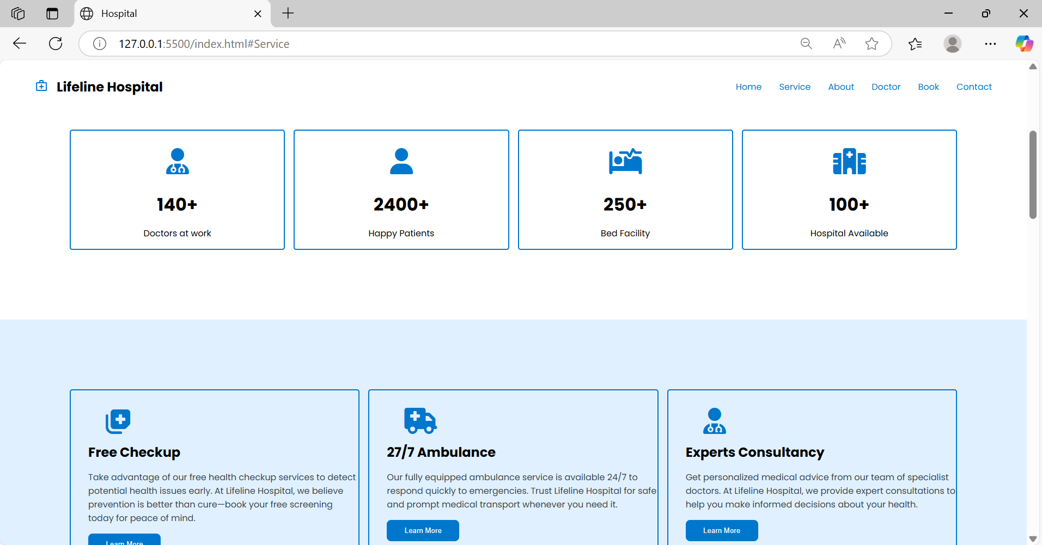
Figure 2: Services Page
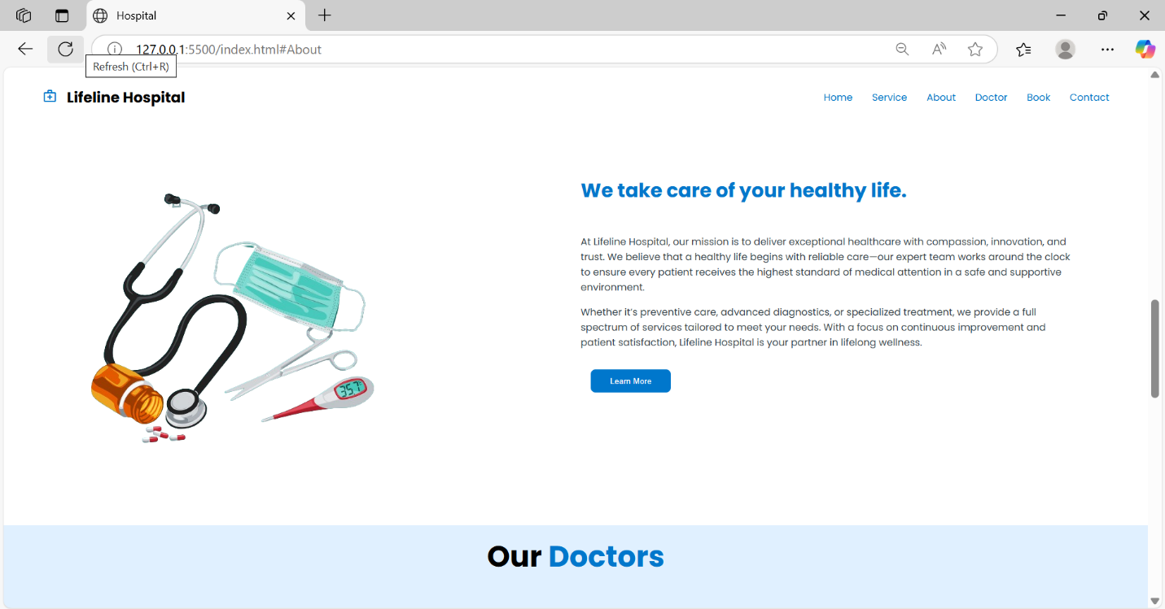
Figure 3: About Page
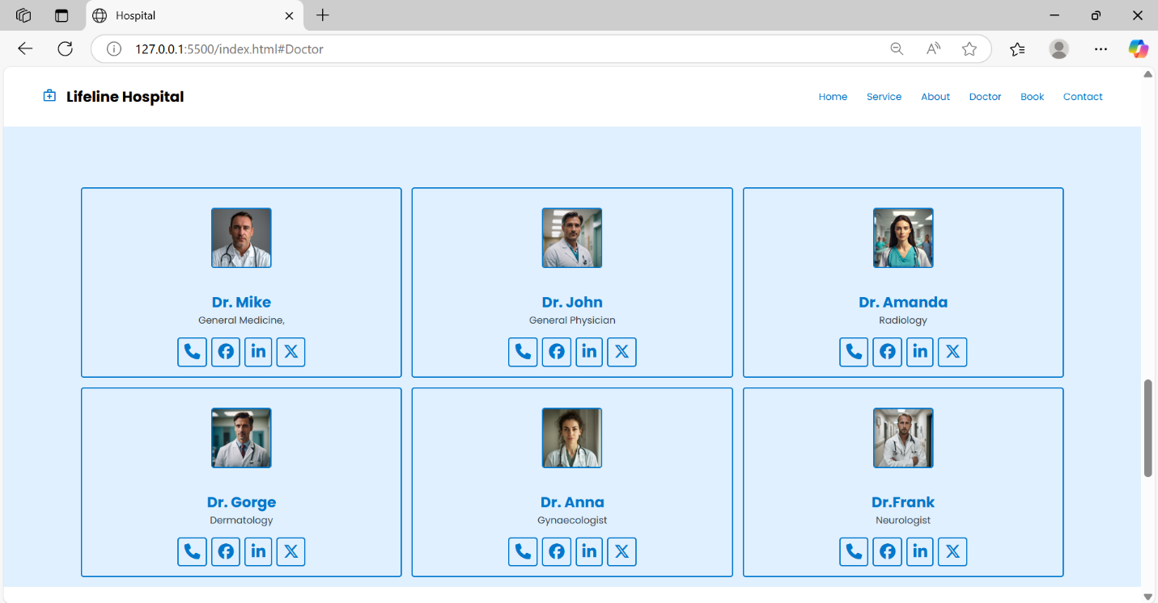
Figure 4: Doctors Page
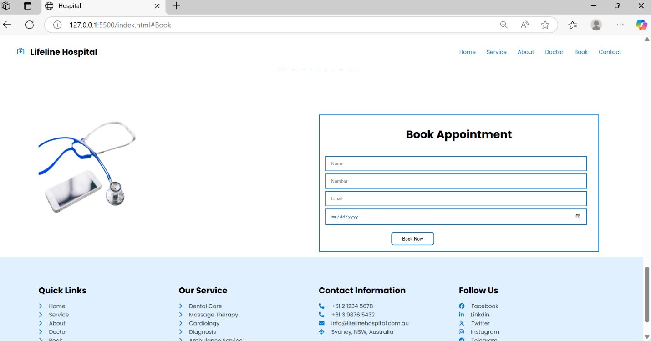
Figure 5: Book Appointment
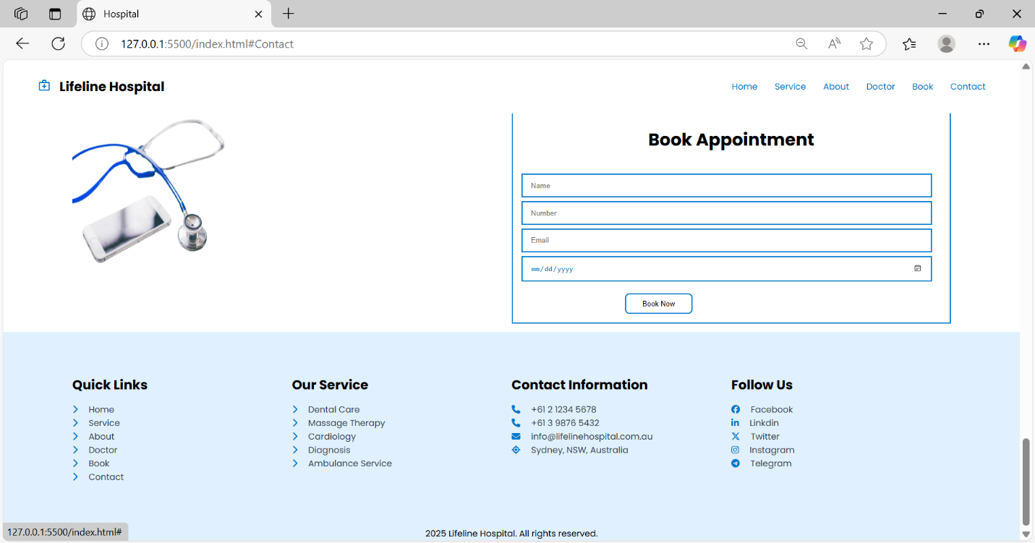
Figure 6: Contact Page

